|  |  |  |  |
| --- | --- | --- | --- |
| **Instructor** |  | **Due Date** |  |

Thoroughly read the objectives, instructions and requirements of each of list quiz packet and then use suitable electronic technology tools to solve the projects. Submit both your program source code, with your name, date and course information in the heading portion of your code, as well as the required output(s).

**Project** ( **Constructing a Web Navigation Page**) **100 Points ___ *score***

**Objective** To design a simple Web Navigator using HTML.

***PROJECT DESCRIPTION***

Design a simple Web navigation page application similar to that shown in **Figure 1** , below.

The initial page consists of a table of four graphic images. The visitor clicks on

an image and then is navigated to the Web site associated with the graphic image

itself, i.e. clicking a music graphic will navigate the visitor to FYE.com and a baseball graphic can take the visitor to ESPN.com, etc.

# Information about This Project

This lab project uses Notepad and Internet Explorer to create an HTML application.

**Figure 1**

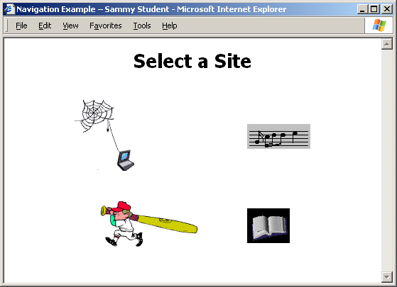

**Project: Constructing a Web Page Navigator**

*Steps To Complete This Project*

**STEP 1** **Open Notepad on Your Computer**

Open the Notepad text editor by using these typical directives:

Click your Desktop Start button, point to Programs , migrate to Accessories .

and point to and click Notepad .

Notepad opens and creates an untitled text file. Save the text file as a Web page file by clicking File on the Notepad menu and selecting Save As … . When the **Save File As** dialog box opens, click the Up One Level icon repeatedly until you reach the Desktop, then click the Create New Folder icon and make a new folder named **MyFiles**. Open the new folder and save the text file as **Navigate.html** to the new folder on your Desktop. Note: to avoid having Notepad adding a **.txt** extension to your file, type double quotes around your filename, " " , such that it will save only with your desired **.html** extension.

Click Save to close the **Save File As** dialog box.

**STEP 2 Download the Images**

Before coding your HTML application, visit a Web site that offers royalty - free, family or business computer animated GIF ( graphics interchange format ) images. One popular site is:

http://www.gifanimations.com

Scroll though the images available at your chosen GIF site. Select four suitable images similar to those shown previously in **Figure 1** . These images are: a computer, a music scale, a baseball player and a book.

To download an image within the GIF site, right - click on a chosen image and select the option Save Picture As . . . . Save the image, using a file name from the list below, to your Desktop **MyPages** folder. Do this for each of the four images.

|  |  |
| --- | --- |
| **File Content** | **File Name** |
| Computer Image | computer.gif |
| Music Image | music.gif |
| Sports Image | baseball.gif |
| Book Image | books.gif |

With the images saved to your **MyPages** folder, return to Notepad and begin coding your HTML application.

**STEP 3** **Write the HTML Web Page Code**

In your Notepad file, begin typing the lines of HTML code / tags listed in **Figure 2** , which follows. Note: replace your own name in place of Sammy Student.

The code basically consists of a two row and two column table which house the four images.

**Project: Constructing a Web Page Navigator**

**Figure 2 HTML Source Code - Web Navigation Page**

|  |
| --- |
|  |

|  |
| --- |
| <html>  <head>  <title>navigation example – sammy student</title>  </head>  <body style = "font-family:Tahoma;">  <div style = "text-align:center;">  <h1>select a site</h1>    <table style = "border-spacing:10px; border-collapse:separate;  margin-left: auto; margin-right: auto;">  <tr>  <td><img src = "computer.gif"></td>  <td><img src = "music.gif"></td>  </tr>  <tr>  <td><img src = "baseball.gif"></td>  <td><img src = "books.gif"></td>  </tr>  </table>  </div>  </body>  </html> |

|  |
| --- |
|  |

After you end your Web page code by typing the closing </HTML> tag, save your completed Web page.

**STEP 4 Preview Your Web Page**

Preview your Web page to ensure that your HTML source code correctly displays the page. To do this, leave Notepad open and navigate to your computer’s Desktop. Locate the Web page entitled **Navigate.html** within the **MyFiles** folder on your Desktop and double - click the file to view it in your Web browser.

Your Web page now appears within Internet Explorer, showing the images within the table. View the page and return to Notepad.

**STEP 5 Modify Your Web Page**

Once you have verified that your Web page is displayed properly within your Web browser, return to Notepad and modify your Web page by adding the HTML code necessary to have the visitor click on an image and a hyperlink

will take them to an underlying Web site.

**Project: Constructing a Web Page Navigator**

To add the navigation capability to your HTML application, locate each <td> tag in your code and supplement the code with an <a> tag containing the link to the associated Web site.

For example, for the computer image, you can modify the table tag code by inserting the <a> anchor tag as shown. Note that the image tag is nested within the anchor tags.

<td>

<a href = "http://www.ibm.com">

<img src = "computer.gif" border = "0">

</a>

</td>

Do this for all of the images. You can use the Web sites listed below for your anchor tags.

|  |  |
| --- | --- |
| **File Content** | **Web Site** |
| Computer Image | http://www.ibm.com |
| Music Image | http://www.fye.com |
| Sports Image | http://www.espn.com |
| Book Image | http://www.bn.com |

**STEP 6 Test your Modified Your Web Page**

Test your modified Web page and then submit screen snapshots and your completed source code for credit.